**CAN/CAN’T**

**Board game**

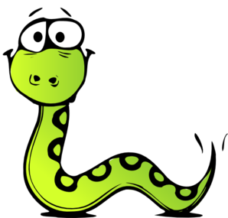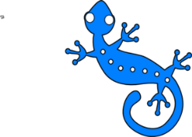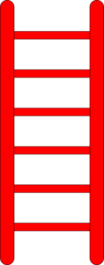

**Can you**

**fly?**

25

**Can you**

**jump?**

35

38

**FINISH**

**Can**

**you**

**run?**

**Can you**

**write?**

30

36

37

34

33

31

32

26

27

28

29

21

20

24

22

23

18

17

16

15

19

9

10

11

12

13

14

8

7

6

5

4

3

2

1

**Can you**

**swim?**

**Can you**

**walk?**

**START**

**Can you**

**climb?**

**Can you**

**read?**

**Can**

**you**

**dance**

**tango?**

**Can you**

**climb?**

**Can you**

**jump?**

**Can you**

**swim?**

**Can you**

**walk?**

**Can you**

**read?**

**Can you**

**sing?**

**Can**

**you**

**play golf?**

**Can you**

**climb?**

**Can you**

**swim?**

**Can you**

**fly?**

**Can you**

**sing opera?**

**Can you**

**play tennis?**

**Can**

**you**

**dance**

**hip-hop?**

**Can you**

**write?**

**Can you**

**fly?**

**Can you**

**run?**

**Can you**

**jump?**